3. Create a react app for Student Management Portal named scorecalculatorapp and create a function component named “CalculateScore” which will accept Name, School, Total and goal in order to calculate the average score of a student and display the same.

Step1:Creating the React App and navigating into the project

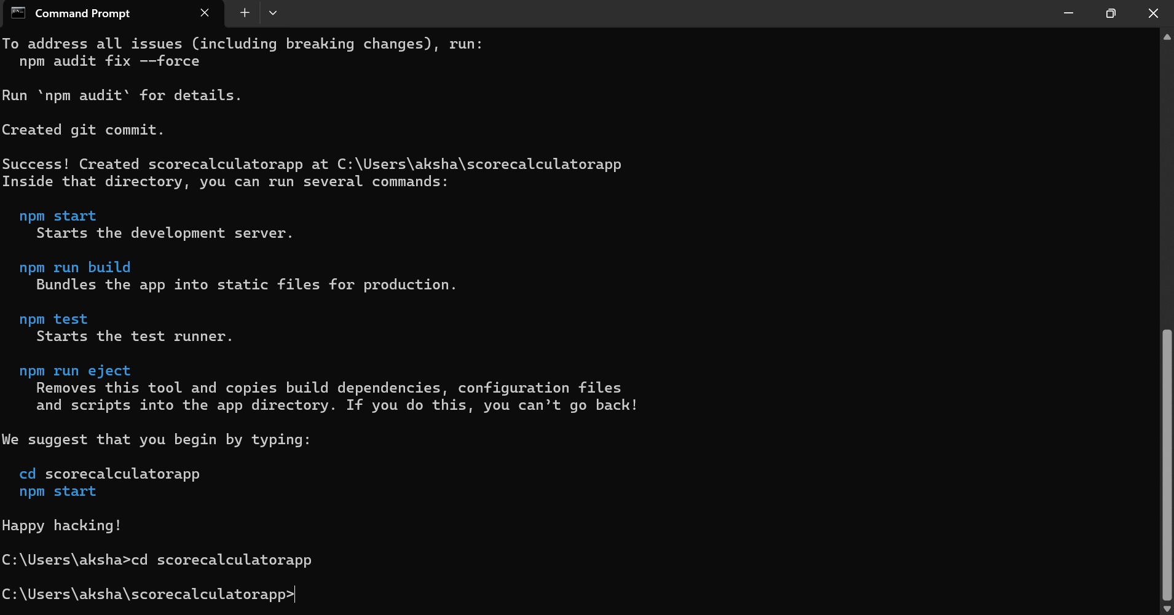

Step2:Creating the components folder

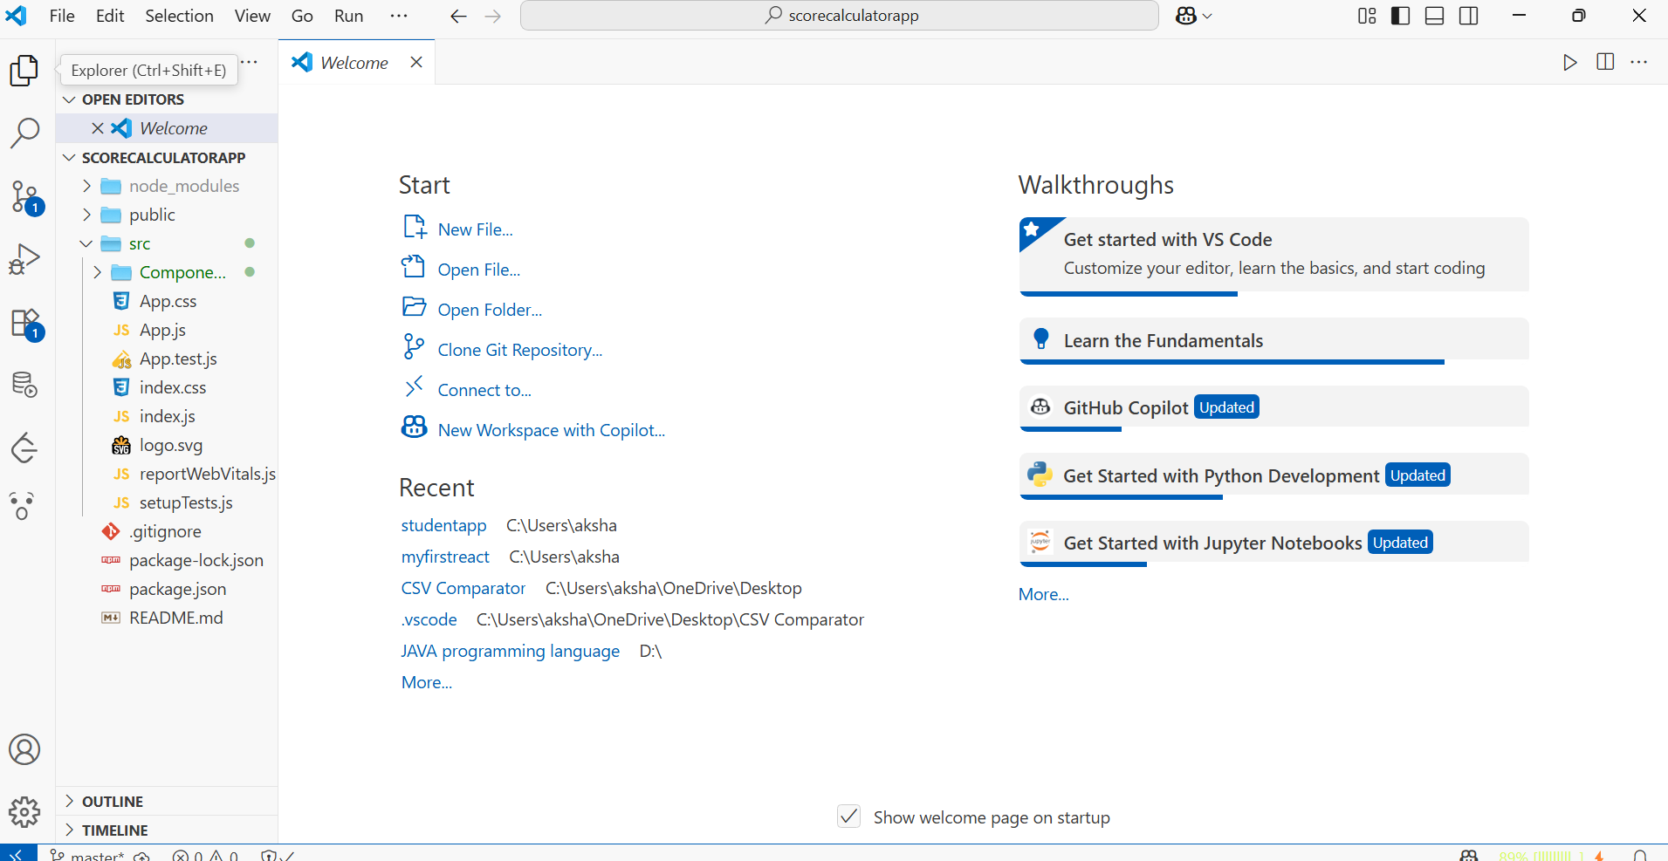

Step3:Creating CalculateScore.js in components and modifying it

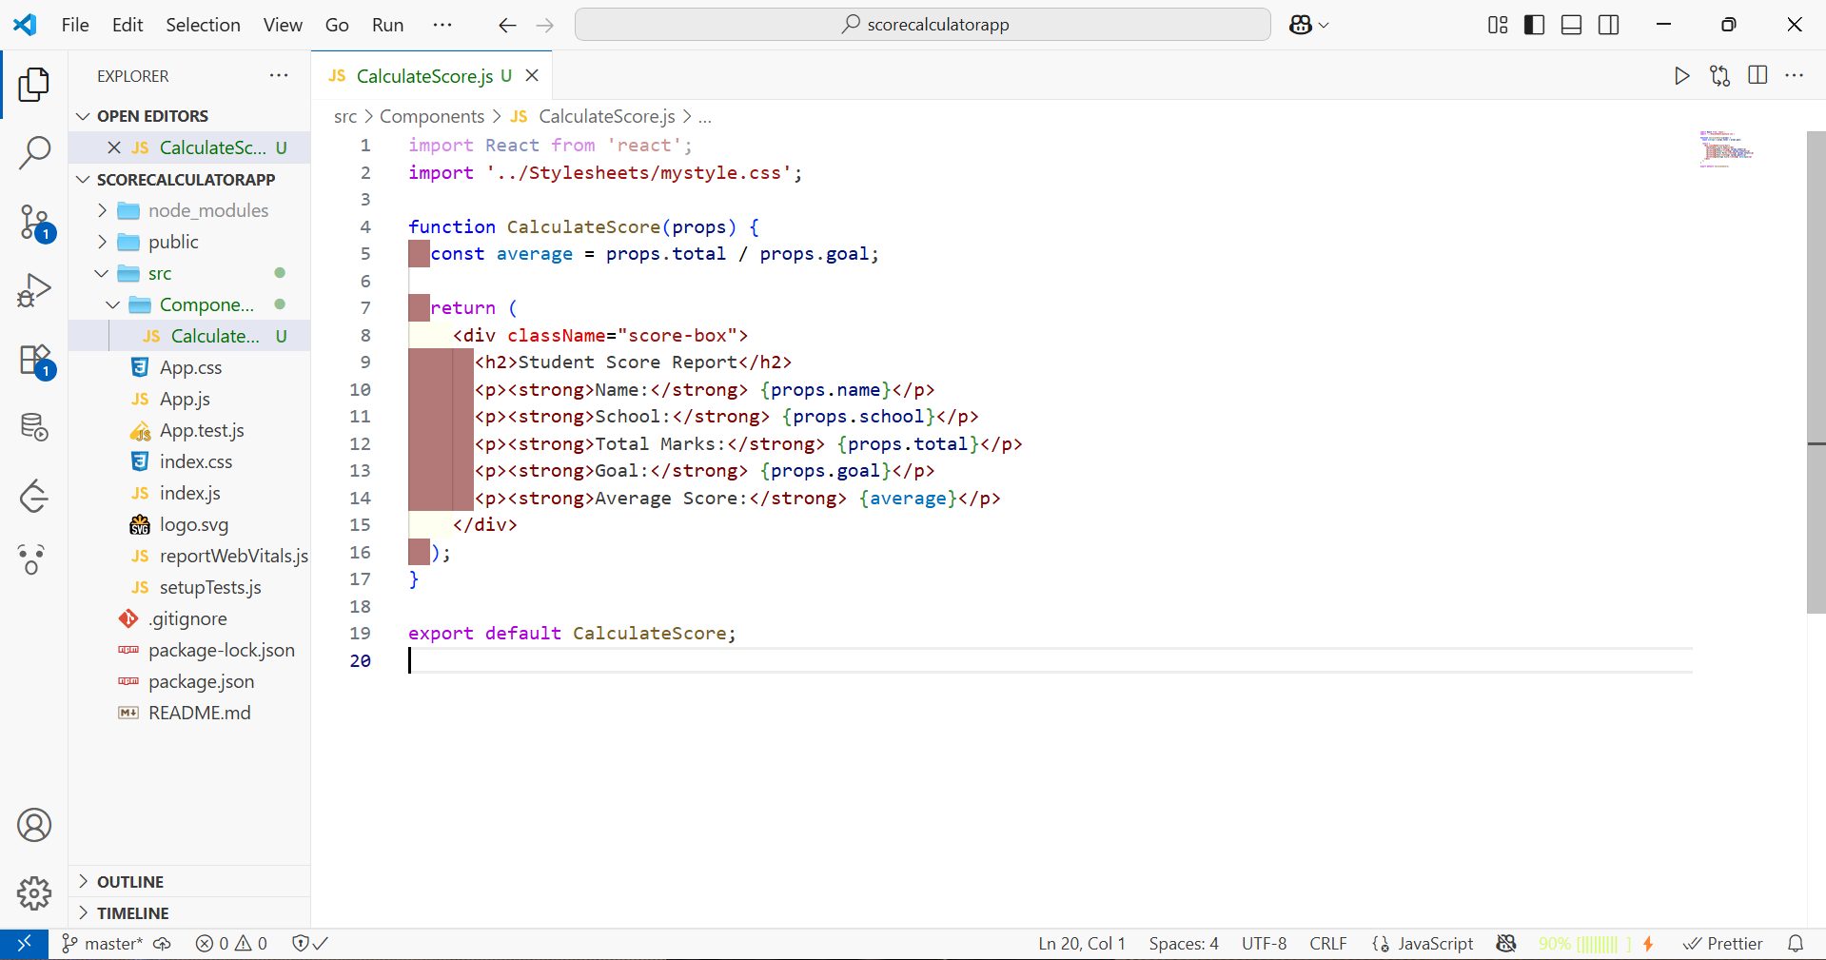

Step4: Creating Stylesheets folder and Adding CSS and Modifying it

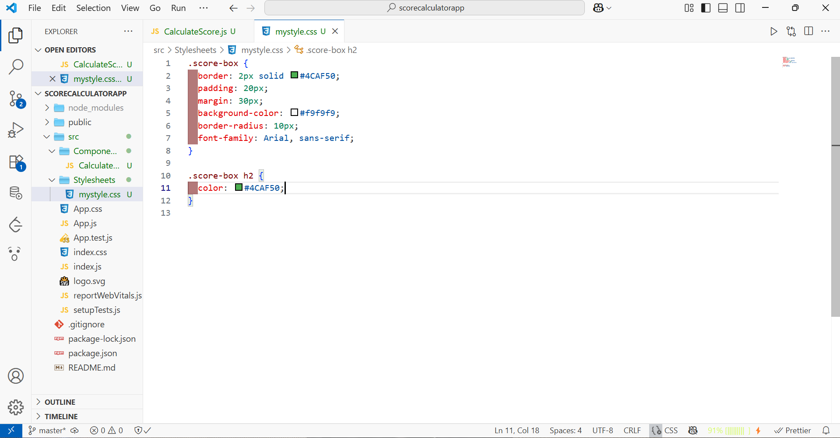

Step5:Modifying App.js

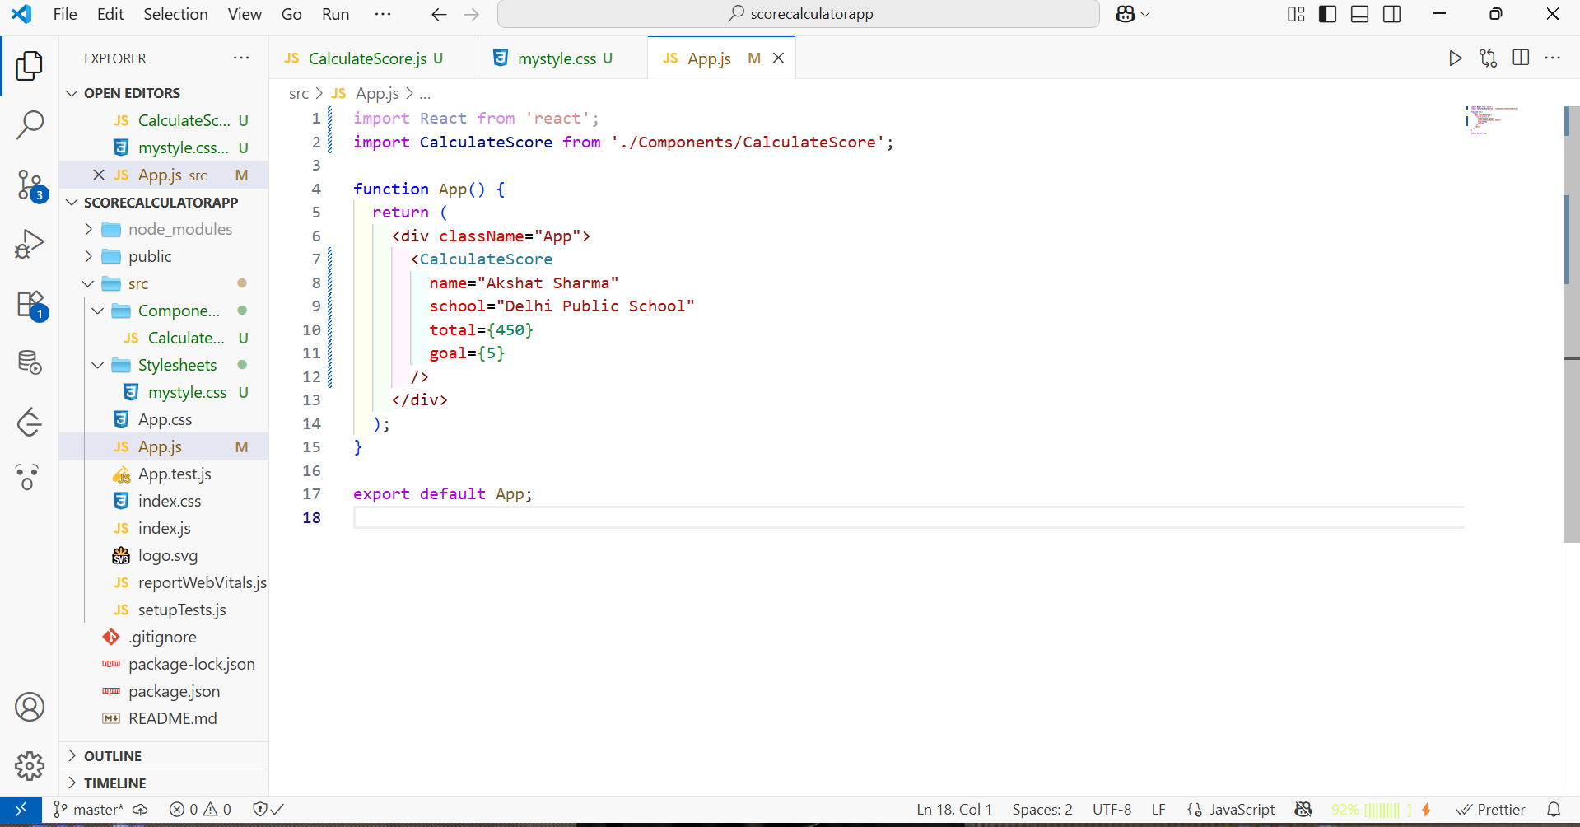

Step5:Starting the React app



